


Scope and Storyboard for Applications

AMR Manchester

By GQL/AKR

Table of Contents

1. Document Revision History 2
1.1. Document Location 2
1.2. Revision History 2
1.3. Approvals 2
1.4. Distribution 2
2. Summary of Scope 3
3. Screen design 3
4. Workflow 8
5. SQL Tables 9
5.1. Table 9
5.2. Lookup 10
5.3. Field 10
6. Stored Procedures 10
6.1. Fetch 10
6.2. Save 10

Document Revision History

Document Location
Full File Path

Revision History
Version Number | Revision Date | Summary of Changes | Changes marked | Author
0.1 | 10-02-2010 | First issue | n/a | GQL
0.2 | 20-07-2011 | Second Issue |  | AKR
0.3 | 02-09-2011 | Added SQL | Yes | SMJ
0.4 | 22/09/2011 | Added Who To Serve Options & table values | Yes | SVR

Approvals
Name | Signature | Title | Date of Issue | Version
Gareth Levingston |  | Senior Business Analyst
Lisa Williams |  | IT Development & Projects Manager

Distribution
Name | Title | Date of Issue | Version

Summary of Scope

This scope describe the provisions that need to be made to the FloCase system in order for it to handle the making and receiving of applications within a matter.

Screen design

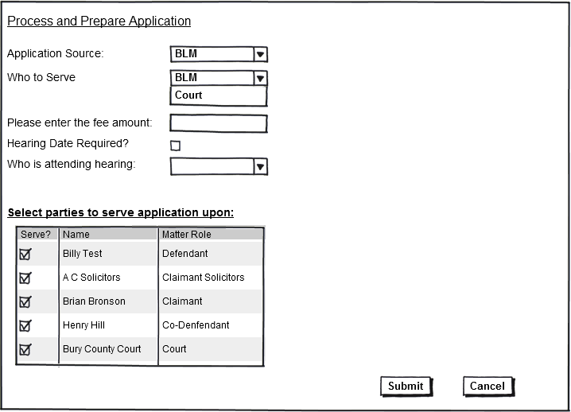
  - Process and Prepare Application

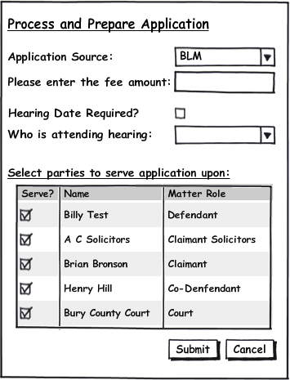

Form Availability
This form will be attached to a new task called Process and Prepare Application which will be picked up on an adhoc basis from the Case Actions page.

Form Behaviour On Load

Upon initial form load there should be no data pre-populated other that the data required by the form items listed below.

Form Items

- Application source: Label as stated with associated Mandatory Combo box having the following options (Populated using LTMM_LookupCodes_Fetch with @LookupTypeCode = 'APPSRCE', @BlankRow = 1)
  - BLM
  - Court
  - Other

- Please enter the fee amount: Currency Field: will only be visible on the form if the user has selected BLM from the application source drop down but should remain non mandatory

- Who to Serve – Label as stated with associated combo box having the following options (Populated using LTMM_LookupCodes_Fetch with @LookupTypeCode = 'APPSRVE', @BlankRow = 1)
  - BLM
  - Court

Field will only be visible on the form if the user has selected BLM from the Application Source drop down and should be mandatory if visible

- Hearing Date Required? Checkbox

- Who is attending hearing: Label as stated with associated Mandatory Combo box having the following options (Populated using LTMM_LookupCodes_Fetch with @LookupTypeCode = 'ATNDHRNG', @BlankRow = 1), should only visible on the form if the user has checked Hearing Date :
  - Fee Earner
  - By Consent
  - Counsel
  - Costs Draftsperson

- Select parties to serve application upon: section will be a grid consisting of all the active contacts of the following types attached to the matter:
  - Defendant
  - Claimant
  - Co-Defendant
  - Third Party Solicitor
  - Court

This grid will only be visible on the form if the user has selected BLM from the application source drop down but should remain non mandatory. The grid should be populated by LTMM_CaseContacts_Fetch passing in the CaseID of the Matter being accessed by the user, this will return all the live contacts attached to the matter.

Form Behaviour on Submit
- Should return to Case Actions page.

- Any contacts checked within the select parties to serve application upon grid will have a copy of the standard application summons created by the system for them. The list of documents produced is listed below:

- If Application Source= BLM and Who to serve = BLM,

  - then produce the following documents for all contacts selected in the field Select parties to serve application upon:
1. Application Notice
2. Internal Cheque Requisition
3. Letter to court enclosing application (BLM to serve)
4. Letter to claimant’s solicitor enclosing application

- If Application Source= BLM and Who to serve = Court,

  - then produce the following documents for all contacts selected in the field Select parties to serve application upon:
1. Application Notice
2. Internal Cheque Requisition
3. Letter to court enclosing application (Court to serve)

- If Application Source= Court or Other then no documents are to be produced

- Upon execution of this task the system should record a history line as follows:
  - If Application Source= BLM then history line = Application to Court made <<Date>>.
  - If Application Source= Court or Other then history line = Application from Court received <<Date>>.

- Upon submission of the Prepare and Process Application the following tasks are scheduled:
- If the user has selected Hearing Date Required, then a reminder task will be scheduled for 7 working days time for the Team Administrator: ‘Notice of hearing received?’.
- If the user has not selected Hearing Date Required then a Task is immediately scheduled for the Lawyer in the Matter: ‘Record Application Result’.

Store procedure to save details entered on the form…..

NOTE: PARTIES TO SERVE APPLICATION ON CAN BE MULTIPLE PEOPLE.
STORED PROC WILL CREATE APPLICATION TO BE SERVED ON EACH PERSON

CREATE PROCEDURE LTMM_Matter_Application_Save
(
@pCaseID INT = 0,
@pAppSource VARCHAR(50) = ‘’,
@pAppSRVE VARCHAR(50) = ‘’,
@pFeeAmount MONEY = 0 -- OPTIONAL,
@pHearingDateReq BIT = 0,
@pAttendingHearing VARCHAR (50) = ‘’ – OPTIONAL,
@pDefendant VARCHAR (MAX) = ‘’ – OPTIONAL,
@pClaimant VARCHAR (MAX) = ‘’ – OPTIONAL,
@pCoDefendant VARCHAR (MAX) = ‘’ – OPTIONAL,
@pThirdPartySol VARCHAR (MAX) = ‘’ – OPTIONAL,
@pMultipleParties BIT = 0 --OPTIONAL
@pCourt VARCHAR (50) = ‘’ – OPTIONAL

AS

DECLARE VARIABLES

GET THE AppTaskID – NEEDS JOINS TO A FEW TABLES

SET SCHEDULE DATE = 7 DAYS FROM TODAY

IF HEARING DATE REQUIRED THEN
IF pMultipleParties = 1, LOOP THROUGH @pDefendant, @pClaimant AND SO ON, AS THESE WILL BE COMMA DELIMITED STRINGS

EXECUTE APPTASK_CREATEPENDING –
PASS IN RELEVANT VALUES WITH SCHEDULE DATE = TODAY + 7 FOR EACH PARTY TO SERVE APPLICATION TO

DESCRIPTION = ‘Have you received notice of hearing?’

ELSE
EXECUTE APPTASK_CREATEPENDING – PASS IN SCHEDULE DATE =TODAY
DO AS ABOVE FOR MULTIPLE PARTIES

DESCRIPTION = ‘Application Result’

Form Behaviour on Cancel
Return to Case Actions page

  - Hearing Date Received (‘Have you received notice of hearing?)

Form Availability
This form should be available from the Pending Tasks page. If the user runs this task the following form will be presented:

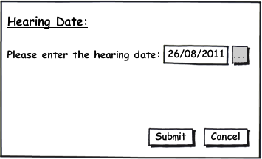

Form Behaviour On Load
The form should load without any data pre-populated

Form Items
1) Please enter the hearing date: Date field
- The hearing date entered in this form will link to the existing Hearing Date Key Date and will
be mandatory.

Form Behaviour on Submit
- Should return to the Pending Tasks page.

- Upon execution of this task the system should record a history line ‘Hearing Date Received: <hearing date>

Store procedure to save details entered on the form…..
‘HEARING’ ALREADY EXISTS AS CaseKeyDates Type

SP TO SAVE HEARING DATE ALREADY EXISTS. POPULATE WITH RELEVANT VALUES:

[LTMM_CaseKeyDates_Save]
(
@CaseKeyDates_CaseKeyDatesID int = 0,
@CaseKeyDates_CaseID int = 0,
@CaseKeyDates_KeyDatesCode nvarchar(10) = '',
@CaseKeyDates_Date smalldatetime = NULL,
@CaseKeyDates_CaseContactsID int = 0,
@CaseKeyDates_OutlookObjectID varchar(255) = '',
@pInactive bit = 0,
@pUsername nvarchar(255)
)

Form Behaviour on Cancel
Return to Pending Tasks page

  - Application Result (Outcome)

Form Availability
This form should be available from the Pending Tasks page. This task will be scheduled:
- on the date of the hearing if a Hearing date was entered or
- immediately if no hearing date was required for the Application. If the user runs this task the following form will be presented:

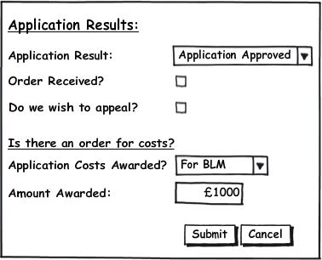

Form Behaviour On Load
The form should load without any pre-populated data

Form Items
- Application Result: Drop down with the following options:
  - Application Approved
  - Application Rejected
  - Vacated By Consent

ADD NEW LOOKUP CODES FOR ‘APPLICATON RESULT’ AND APPLICATION COSTS AWARDED’ ABOVE USING LTMM_LOOKUPCODES_SAVE

2) Order Received? Checkbox

3) Do we wish to appeal? check box will be disabled and unchecked unless the user checks the Order Received Check box.

4) Application Costs Awarded? Dropdown will be disabled unless the user checks the Order Received checkbox. Drop down will have the following options and be mandatory:
- No Order
- For BLM
- Against BLM
- Costs in the case

Amount Awarded: field will only display if the user selects ‘For BLM’ or ‘Against BLM’ in the Application Costs Awarded field.

Form Behaviour on Submit
- Should return to Pending Tasks page.

- Upon execution of this task the system should record a history lines as follows:
- If Application Approved is selected then –‘Application has been approved’
- If Application Rejected is selected then –‘Application has been rejected’
- If Vacated by Consent is selected then – ‘Application Vacated by Consent’
- If Applications Costs Awarded is For BLM then-
Application Results: <Amount Awarded> Awarded For BLM
- If Applications Costs Awarded is Against BLM then-
Application Results: <Amount Awarded> Awarded Against BLM
- If Applications Costs Awarded is Costs in the case then- Application Results: <Amount Awarded> Awarded for costs in the case.

- If Do you wish to appeal is selected, a reminder task is immediately scheduled ‘Appeal application result’

Store procedure to save details entered on the form…..

LTMM_ApplicationOutcome_Save:

CREATE PROCEDURE LTMM_ApplicationOutcome_Save
(
@pCaseID INT
@pApplicationSource VARCHAR(50),
@pFeeAmount MONEY= 0,
@pHearingDate DATEIME,
@pAttendingHearing VARCHAR(50),
@CaseContactID INT,
@CaseContactType VARCHAR(50),
@CaseContactName VARCHAR(50),
@ApplicationResult VARCHAR(50),
@pOrderRecieved BIT DEFAULT (0),
@pAppealWanted BIT DEFAULT (0),
@pAppCostsAwarded VARCHAR(50),
@pAmountAwarded MONEY DEFAULT (0),
@pUserName VARCHAR(50)
)

AS
INSERT INTO ApplicationOutcome (Column list…)
SELECT @CaseID,
Rest of parameter list
……
GETDATE() – CREATE DATE

---CHECK IF REMINDER REQUIRED
IF @pAppealWanted = 1
SET SCHEDULE DATE = TODAY
EXECUTE APP_CREATEPENDING

Form Behaviour on Cancel
Return to Pending Tasks page

Workflow
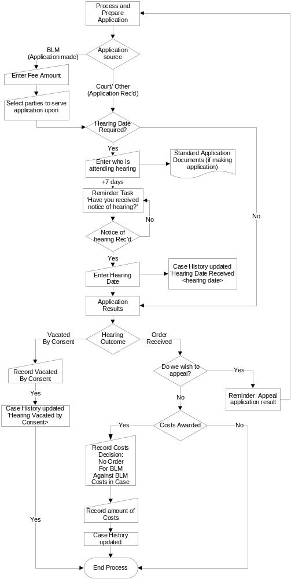

In the above diagram the following scheduling should apply:
- The Reminder, Have you received notice of hearing? should be scheduled for the Lawyer on the matter 7 days after the Prepare and Process Application task.
- The Application Results task should be scheduled for the Lawyer on the matter on the Hearing Date entered within the Hearing Date task
- The Reminder, Appeal application result should be scheduled for the Lawyer immediately after the Application Result Task and present the Process and Prepare form.

The remaining actions should be scheduled immediately upon completion of their predecessors with all tasks being scheduled for the Lawyer.

Navigation

Where will the Flow be launched from

The Application flow will be start upon the user running the Process and Prepare Application task from the Case Actions screen.

Where should the Flow return to

The Application flow will return to the Pending tasks screen.

SQL Tables

Table

ApplicationOutcome:

USE [FloSuite_Data_Dev]
GO

SET ANSI_NULLS ON
GO

SET QUOTED_IDENTIFIER ON
GO

SET ANSI_PADDING ON
GO

CREATE TABLE [dbo].[ApplicationOutcome](
[ApplicationOutcomeID] [int] IDENTITY(1,1) NOT NULL,
[CaseID] [int] NOT NULL,
[ApplicationSource] [varchar](50) NULL,

[FeeAmount] [money] NULL,
[HearingDate] [datetime] NULL,
[AttendingHearing] [varchar](50) NULL,
[CaseContactID] [int] NOT NULL,
[CaseContactType] [varchar](50) NOT NULL,
[CaseContactName] [varchar](50) NOT NULL,
[ApplicationResult] [varchar](50) NOT NULL,
[OrderRecieved] [bit] NULL,
[AppealWanted] [bit] NULL,
[AppCostsAwarded] [varchar](50) NOT NULL,
[AmountAwarded] [money] NULL,
[CreateUser] [varchar](50) NULL,
[CreateDate] [datetime] NULL,
CONSTRAINT [PK_ApplicationOutcome] PRIMARY KEY CLUSTERED
(
[ApplicationOutcomeID] ASC
)WITH (PAD_INDEX = OFF, STATISTICS_NORECOMPUTE = OFF, IGNORE_DUP_KEY = OFF, ALLOW_ROW_LOCKS = ON, ALLOW_PAGE_LOCKS = ON) ON [PRIMARY]
) ON [PRIMARY]

GO

SET ANSI_PADDING OFF
GO

ALTER TABLE [dbo].[ApplicationOutcome] ADD DEFAULT ('Awaiting Decision') FOR [ApplicationResult]
GO

ALTER TABLE [dbo].[ApplicationOutcome] ADD DEFAULT ((0)) FOR [OrderRecieved]
GO

ALTER TABLE [dbo].[ApplicationOutcome] ADD DEFAULT ((0)) FOR [AppealWanted]
GO

ALTER TABLE [dbo].[ApplicationOutcome] ADD DEFAULT ((0)) FOR [AmountAwarded]
GO

Lookup

New lookup for Application Source having a LookupTypeCode of ApSource with the following options:
- BLM
- Court
- Other

New lookup for Who to Serve having a LookupTypeCode of AppSRVE with the following options:
- BLM
- Court

New lookup for Who is attending hearing having a LookupTypeCode of ApAttendance with the following options:
:
- Fee Earner
- By Consent
- Counsel
- Costs Draftsperson

New lookup for Application Costs Awarded having a LookupTypeCode of ApCostAwarded with the following options:
- For BLM
- Against BLM
- Costs in the case

Field
The only new field requirements are those described within the new tables section above.

Stored Procedures

Fetch

Save

Document Template

Status:  New / Existing/ Replacement  (please state) | Received Document Name (from business) | Document File Name  (ie Document.dot) | Document Description  (as viewed on FloCase) | Template Description Code  (Code for auto description) | Template Group:  BLM/ Documents/ Court Doc/ Letters/ Other | Availability? (Flow Only, Ad hoc or Both)
WorkFlow: After Processing Application Form/screen
Existing | Application Notice | Court_N244_AppNotice.dot | Application notice | App. Not. | Court Documents | Both
Existing | Witness Statement | Witness_Statement.dot | Witness Statement | Wit. Stat. | Court Documents | Ad hoc
New | Internal Cheque Requisition | BLM_Requisition_Cheque.dot | Cheque Requisition | Chq. Req | Document | Both
New | Letter to court enclosing application (court to serve) | Court_Letter_AppNotice_CrtSrv.dot | Letter to Court enclosing Application Notice (Court to serve) | Ltr. Crt AppNotice CrtSrv | Letter | Flow Only
New | Letter to court enclosing application (BLM to serve) | Court_Letter_AppNotice_BLMSrv.dot | Letter to Court enclosing Application Notice (BLM to serve) | Ltr. Crt AppNotice BLMSrv | Letter | Flow Only
New | Letter to claimant’s solicitor enclosing application | ClaimSol_Letter_AppNotice.dot | Letter to Claimant Solicitor enclosing Application Notice | Ltr. ClaimSol AppNotice | Letter | Flow Only
New | Consent Order | Court_ConsentOrder.dot | Consent Order | Consent Order | Document | Ad hoc
New | Certificate of Urgency | Court_CertificateUrgency.dot | Certificate of Urgency | Cert. Urgent | Document | Ad hoc
WorkFlow: After Hearing Date entered
New | Brief to counsel | Counsel_Brief_Trail.dot | Brief to Counsel to Attend Trial | Brief. Cnsl | Document | Ad hoc (In Instructions To counsel scope)
New | Ad hoc letter to Counsel enclosing Brief | Counsel_Letter_Brief.dot | Letter to Counsel enclosing Brief | Ltr. Cnsl enc Brief | Letter | Ad hoc (In Instructions To counsel scope)
Existing | Memorandum | Memo.dot | Memorandum | Memo. | BLM | Ad hoc
WorkFlow: After enter Application results
New | Non delegated Case Advice/Update Report | Client_Report_AdviceUpdateNonDel.dot | Case Advice Update Report (Non Delegated) | Rep. NonDel AdvUpdate | Document | Ad hoc
Existing | Zurich Offshore Payment Request Form | Payment_Request_Zurich.dot | Payment Request Form | Pay. Req. | Documents | Ad hoc
For information purposes –Information from Zurich Team (VYE) on documents required:

Processing application
- Application notice
- Supporting witness statement from lawyer
- Internal/ non-offshore cheque requisition for court fee (currently £80)
- Letter to court enclosing application (2 precedents if court to serve or if BLM to serve)
- Consent Order
- Certificate of urgency.
Hearing date
- Will need to brief counsel possibly so need docs for that = ’Brief to Counsel’ Brief to Counsel will be flow only for applications but will need to be ad hoc too for other occasions.
- If someone else internally to go need Memo - i.e. costs draftsperson or other person at an office closer to the court. = ‘Memorandum’
Application results
- Ad hoc advice to client re. result = Non delegated Case Advice/Update Report
- Possibly offshore payment request if order of costs made against BLM. = Zurich Offshore Payment Request Form

/tmp/lo/0000.doc

